Create VPC

1. Two AZs
2. Private and public subnet in each AZ
3. Public and Private route table and attached with Subnet
4. Internet gateway attached with Public Subnet

AWSTemplateFormatVersion: 2010-09-09

Description: Deploy a VPC

Resources:

VPC:

Type: AWS::EC2::VPC

Properties:

CidrBlock: 10.0.0.0/16

EnableDnsHostnames: true

Tags:

- Key: Name

Value: pras VPC

InternetGateway:

Type: AWS::EC2::InternetGateway

Properties:

Tags:

- Key: Name

Value: pras Internet Gateway

AttachGateway:

Type: AWS::EC2::VPCGatewayAttachment

Properties:

VpcId: !Ref VPC

InternetGatewayId: !Ref InternetGateway

PublicSubnet1:

Type: AWS::EC2::Subnet

Properties:

VpcId: !Ref VPC

CidrBlock: 10.0.0.0/24

AvailabilityZone: !Select

- '0'

- !GetAZs ''

Tags:

- Key: Name

Value: Public Subnet 1

PrivateSubnet1:

Type: AWS::EC2::Subnet

Properties:

VpcId: !Ref VPC

CidrBlock: 10.0.1.0/24

AvailabilityZone: !Select

- '0'

- !GetAZs ''

Tags:

- Key: Name

Value: Private Subnet 1

PublicSubnet2:

Type: AWS::EC2::Subnet

Properties:

VpcId: !Ref VPC

CidrBlock: 10.0.2.0/24

AvailabilityZone: !Select

- '1'

- !GetAZs ''

Tags:

- Key: Name

Value: Public Subnet 2

PrivateSubnet2:

Type: AWS::EC2::Subnet

Properties:

VpcId: !Ref VPC

CidrBlock: 10.0.3.0/24

AvailabilityZone: !Select

- '1'

- !GetAZs

Ref: AWS::Region

Tags:

- Key: Name

Value: Private Subnet 2

PublicRouteTable:

Type: AWS::EC2::RouteTable

Properties:

VpcId: !Ref VPC

Tags:

- Key: Name

Value: Public Route Table

PublicRoute:

Type: AWS::EC2::Route

Properties:

RouteTableId: !Ref PublicRouteTable

DestinationCidrBlock: 0.0.0.0/0

GatewayId: !Ref InternetGateway

PublicSubnetRouteTableAssociation1:

Type: AWS::EC2::SubnetRouteTableAssociation

Properties:

SubnetId: !Ref PublicSubnet1

RouteTableId: !Ref PublicRouteTable

PublicSubnetRouteTableAssociation2:

Type: AWS::EC2::SubnetRouteTableAssociation

Properties:

SubnetId: !Ref PublicSubnet2

RouteTableId: !Ref PublicRouteTable

PrivateRouteTable:

Type: AWS::EC2::RouteTable

Properties:

VpcId: !Ref VPC

Tags:

- Key: Name

Value: Private Route Table

PrivateSubnetRouteTableAssociation1:

Type: AWS::EC2::SubnetRouteTableAssociation

Properties:

SubnetId: !Ref PrivateSubnet1

RouteTableId: !Ref PrivateRouteTable

PrivateSubnetRouteTableAssociation2:

Type: AWS::EC2::SubnetRouteTableAssociation

Properties:

SubnetId: !Ref PrivateSubnet2

RouteTableId: !Ref PrivateRouteTable

Outputs:

VPC:

Description: VPC

Value: !Ref VPC

AZ1:

Description: Availability Zone 1

Value: !GetAtt

- PublicSubnet1

- AvailabilityZone

AZ2:

Description: Availability Zone 2

Value: !GetAtt

- PublicSubnet2

- AvailabilityZone

Screenshot of Stack and resource created:

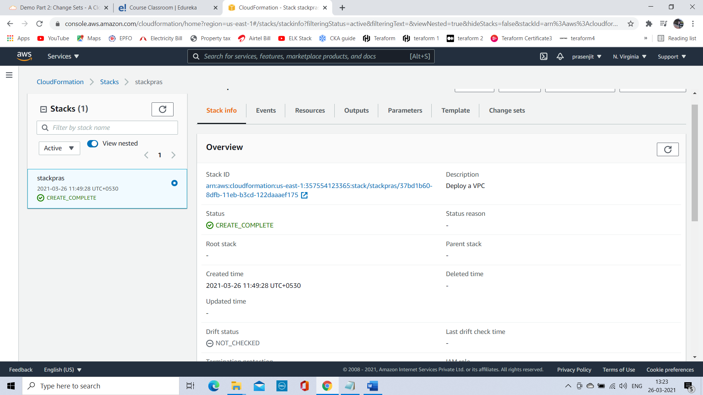

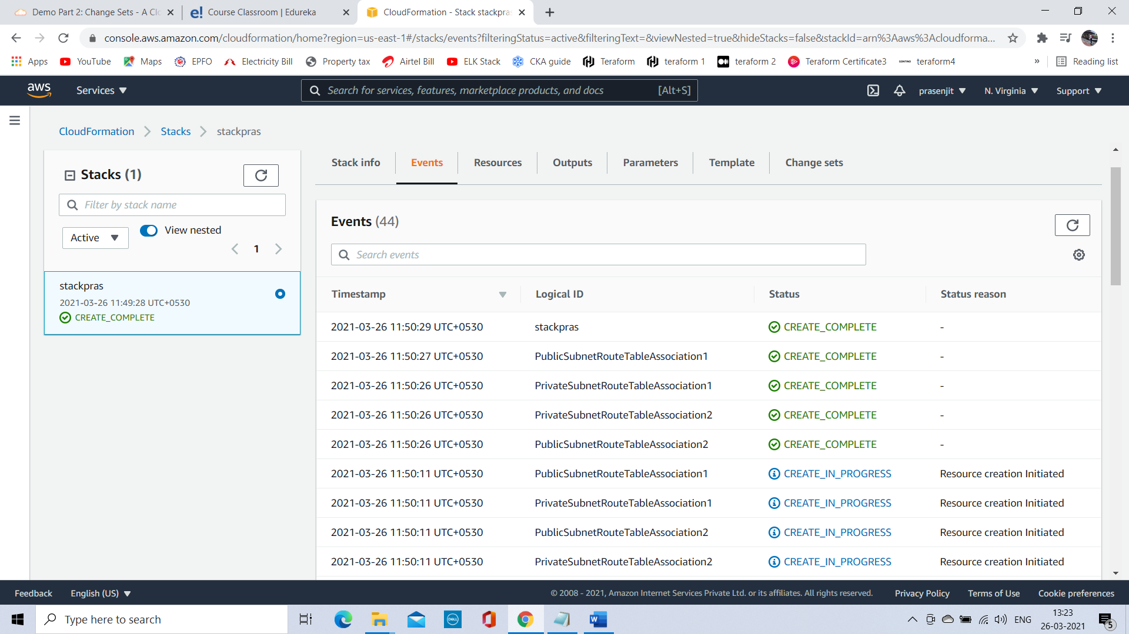

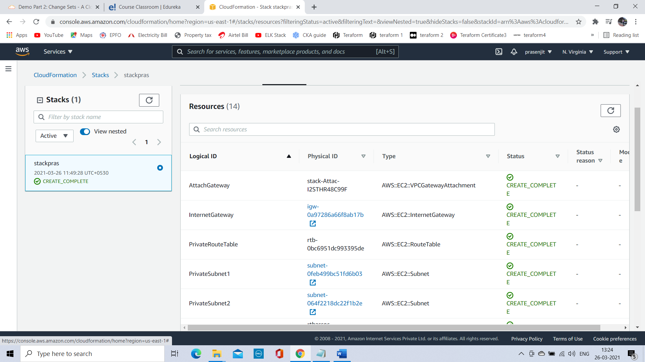

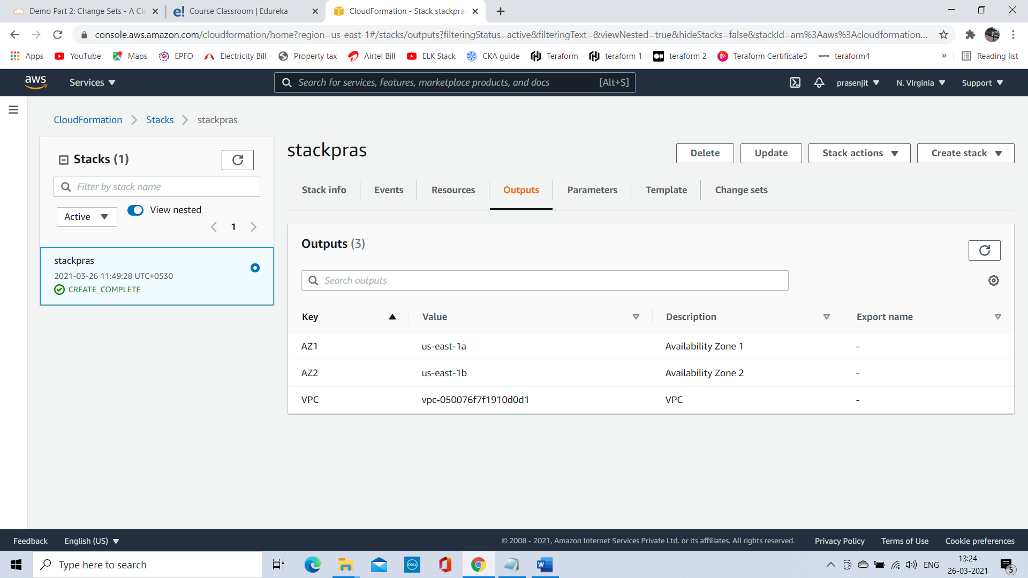

VPC:

VPC created with name Pras VPC:

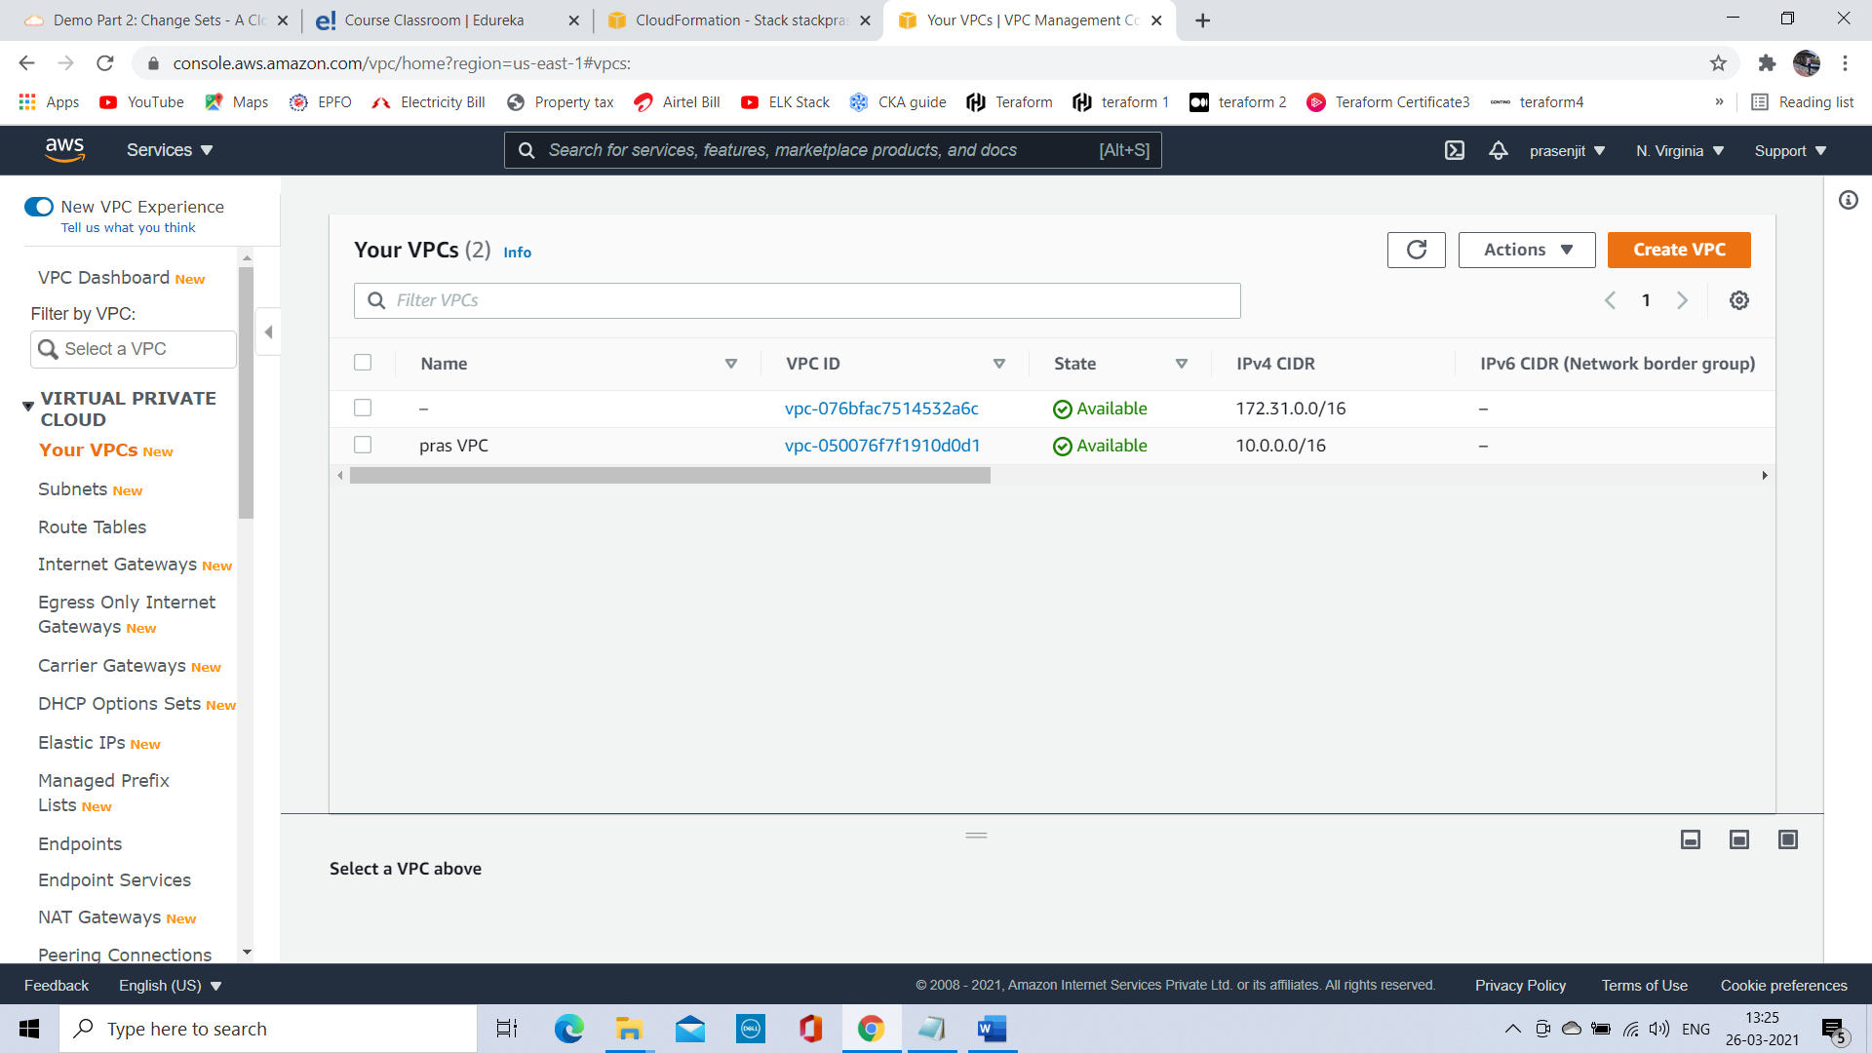

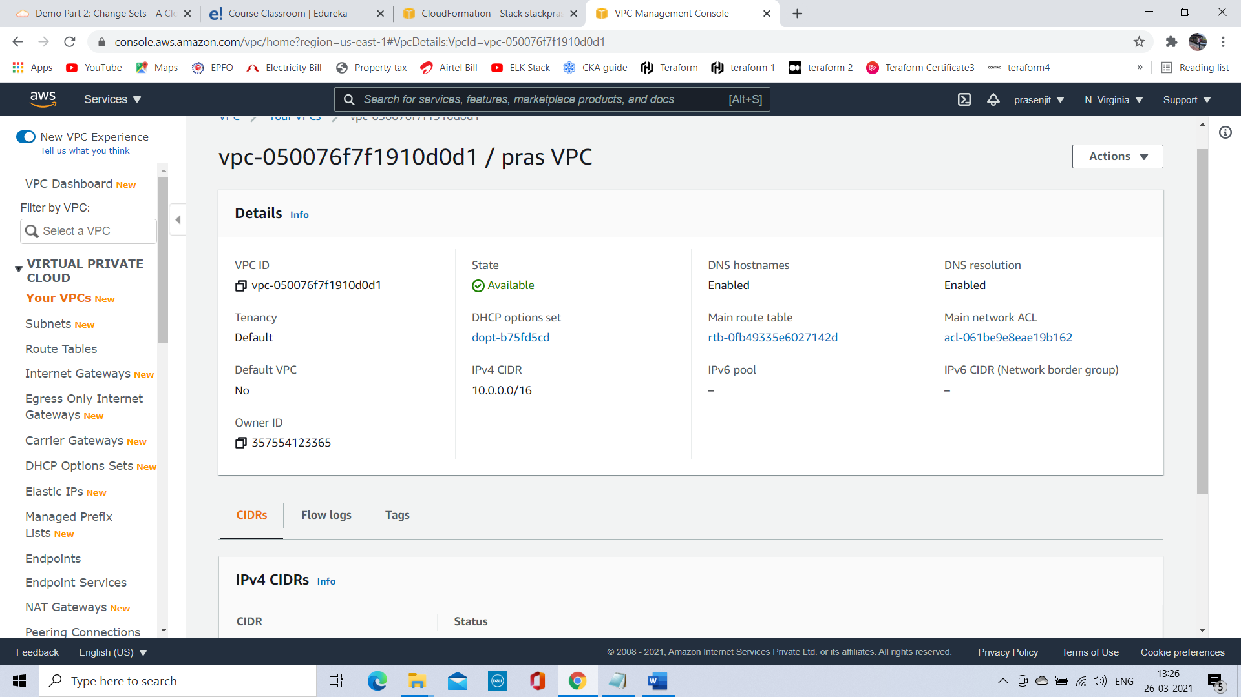

Four Subnet with name created:

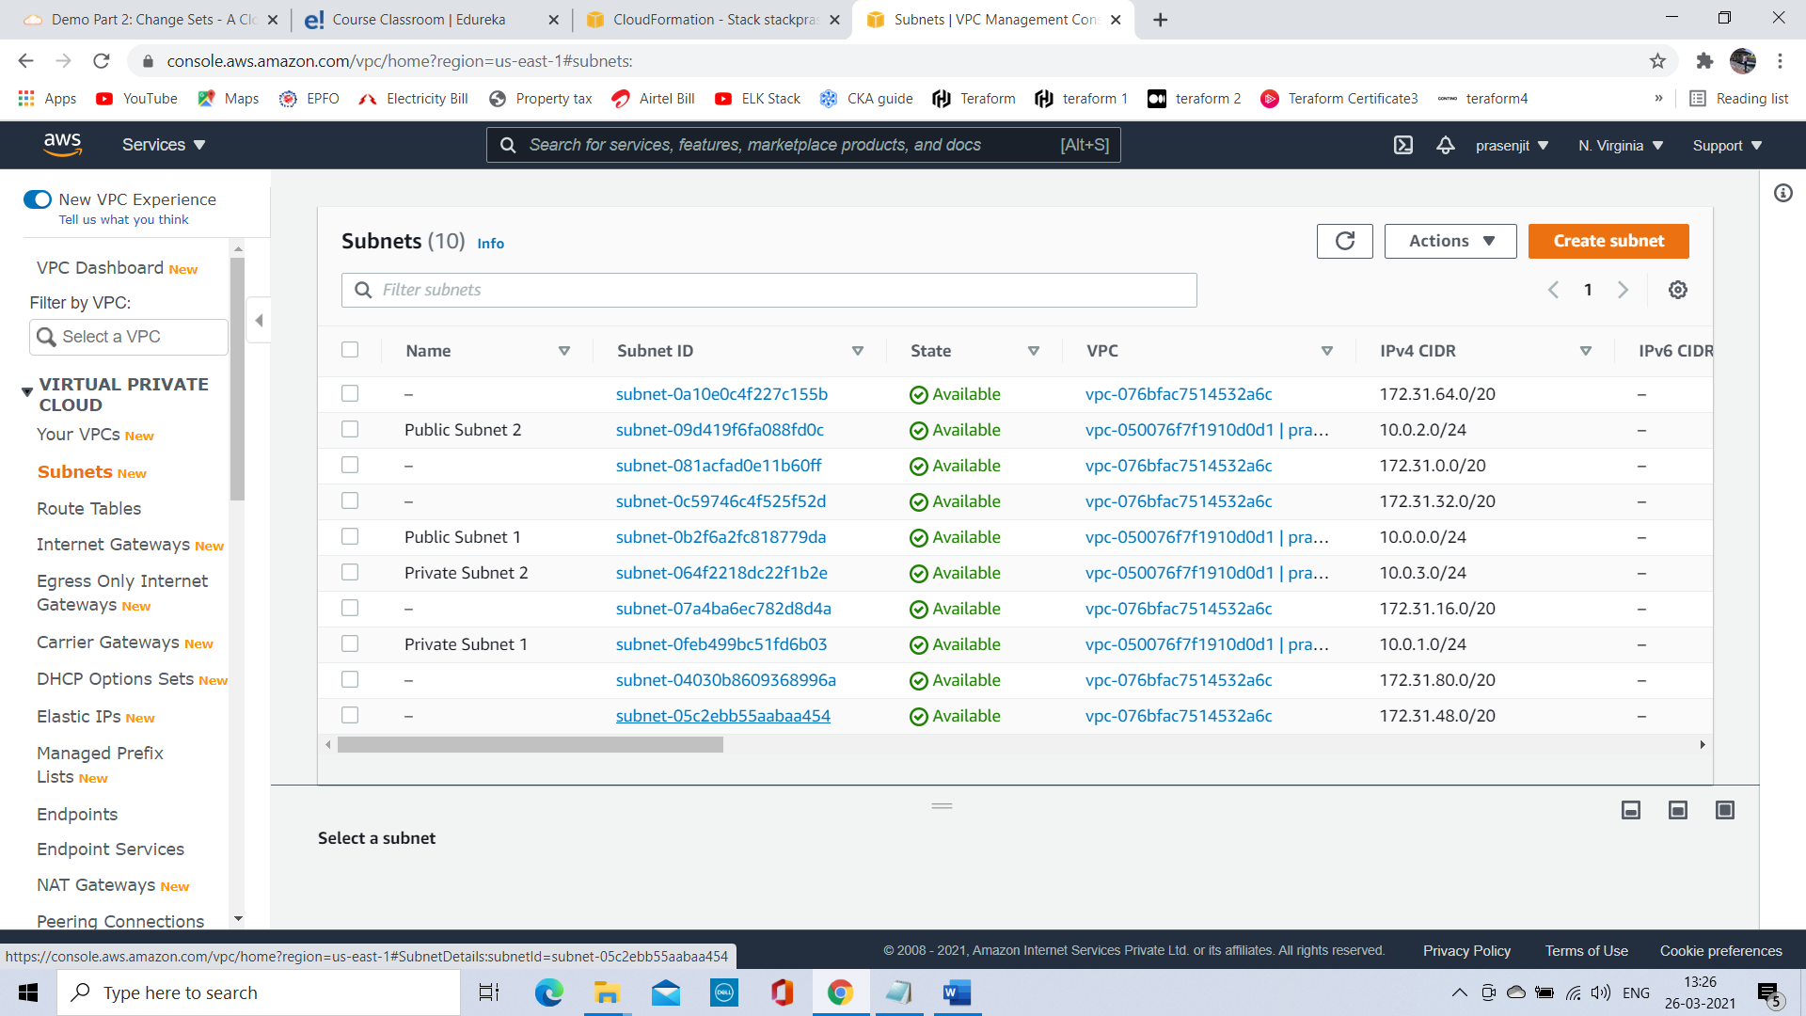

Public subnet associated with IG:

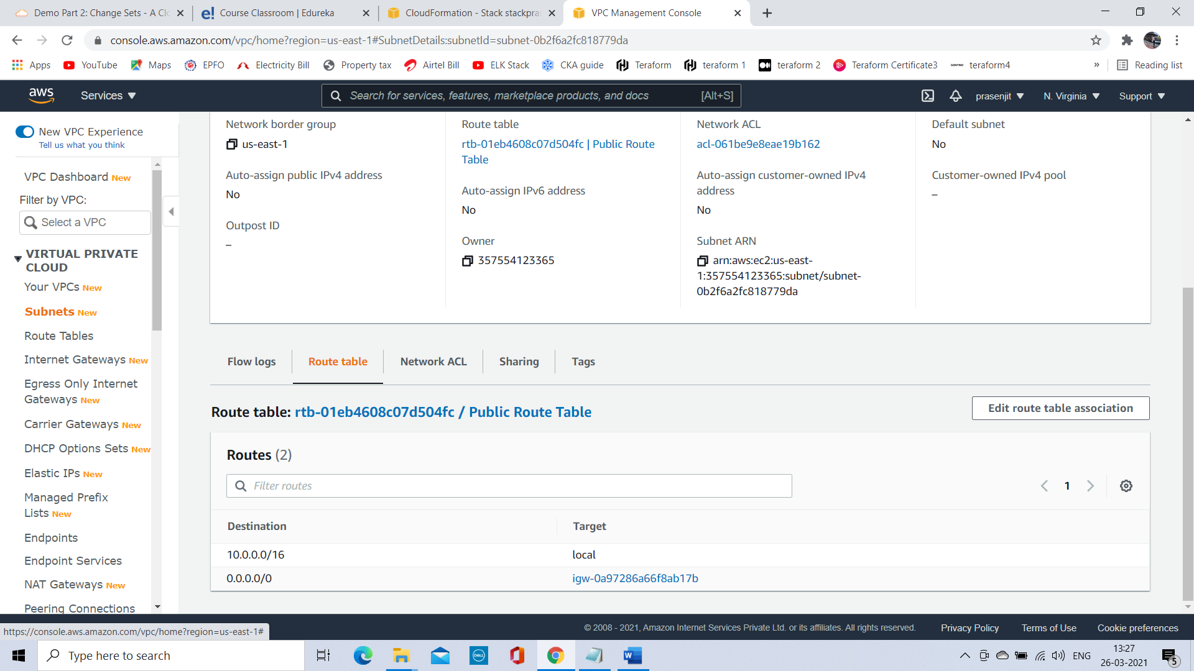

Internet gateway created:

IG created and attached with VPC ID:

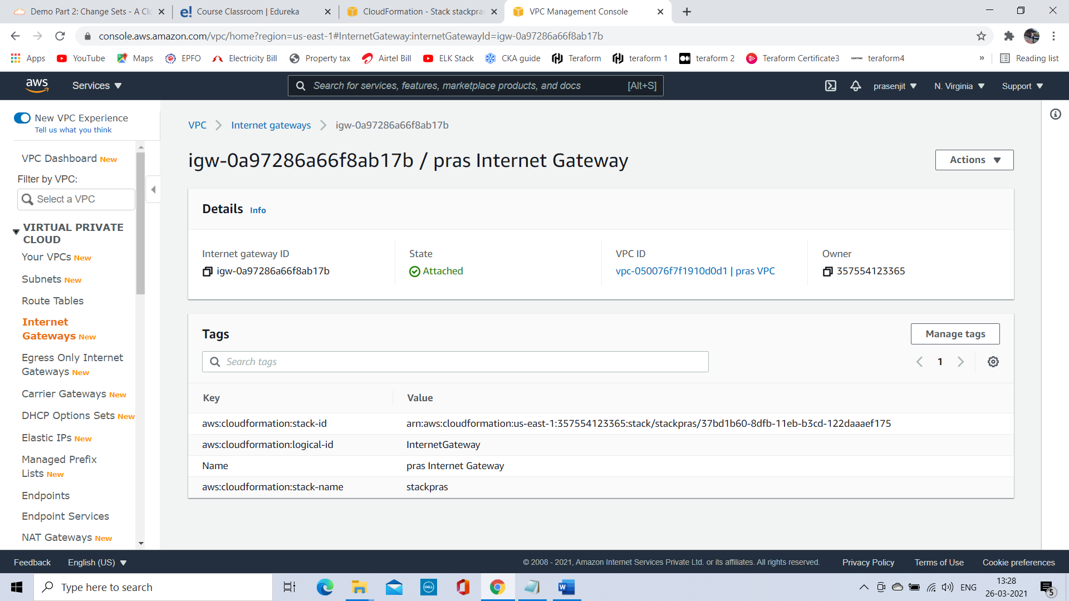

Route table created for public and private:

